|  |
| --- |
| Virtual Reality Laboratory in the Munroe Meyer Institute |
| cometrics |
| User Guide |

|  |
| --- |
| Hurtz, Morgan L | Arce, Walker | Walker, Seth, PhD, BCBA-D  3-22-2022 |

**Contents**

|  |  |  |
| --- | --- | --- |
| Section 1: Open Program |  | 2 |
| Section 2: Start Menu |  | 4 |
| Section 3: Project Setup |  | 5 |
| Section 4: Keystroke File Setup |  | 7 |
| Section 5: Patient Information |  | 9 |
| Section 6: Session Times |  | 12 |
| Section 7: Keybindings |  | 13 |
| Section 8: E4 Streams |  | 16 |
| Section 9: Video View |  | 19 |
| Section 10: Quick Access Menu |  | 24 |
| Section 11: Keystroke File Format |  | 25 |
| Section 12: Interobserver Agreement Coefficients |  | 26 |
| Section 13: Session Output File Format |  | 28 |
| Section 14: Configuration Changes |  | 29 |
| Section 15: Understanding Webcam Order |  | 30 |
| Section 16: Modifying Keystroke Files |  | 31 |
| Section 17: Connecting External Input |  | 32 |
| Section 18: Reporting Bugs and Other Issues |  | 34 |
| Section 19: Woodway Split Belt Treadmill Support |  | 36 |
| Section 20: BLE Peripheral Support |  |  |

**Section 1** Open Program

* 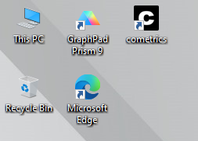 ==
* Locate the **cometrics** icon on desktop

OR

* Search “**cometrics**” in the Windows search bar (bottom left of screen)

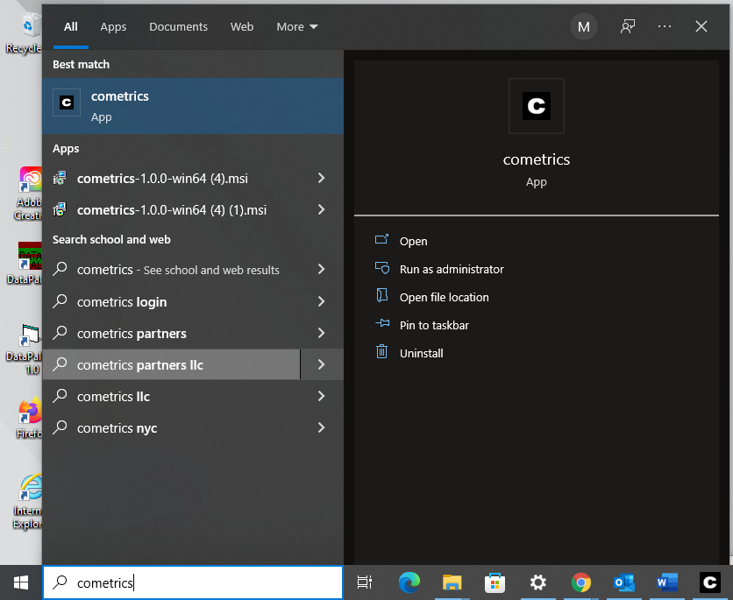=

**Section 1** Open Program (cont.)

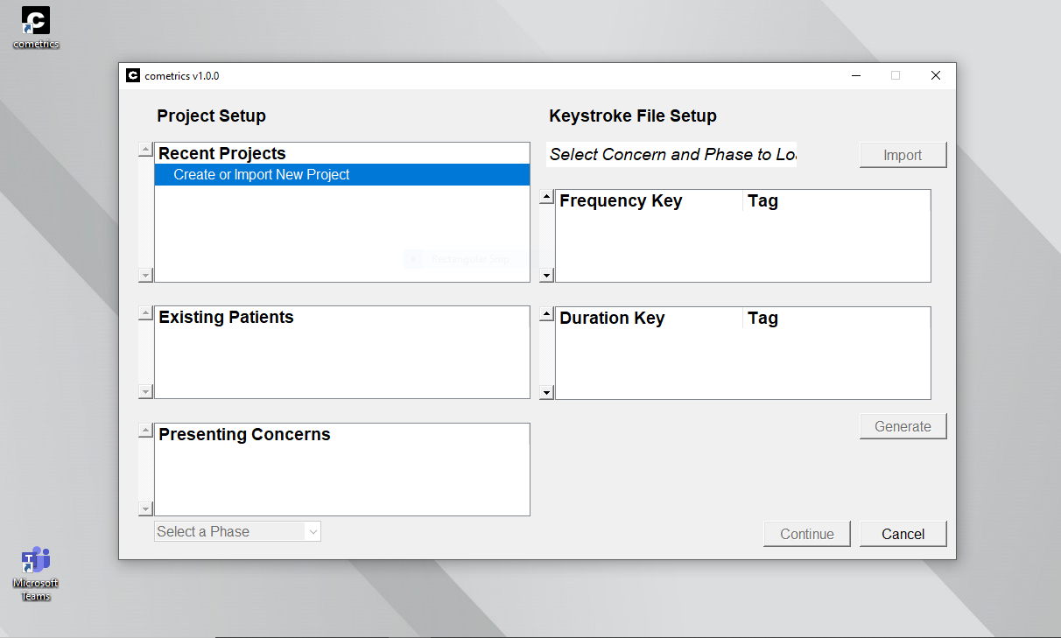



* **Start Menu** will open

**Section 2**  Start Menu

**Two Sections of Start Menu:**

Project Setup Keystroke File Setup

Pressing **Create or Import New Project** will open the above window. The default save directory can be changed using the folder icon. Existing projects can be imported using the **Import** button

**Section 3** Project Setup



* **Recent Projects** tab is used for creating and importing projects
* **Existing Patients** tab shows which patient is being studied in each session
* **Presenting Concerns** tab shows what behaviors are being recorded / analyzed in the session

**Section 3** Project Setup (cont.)

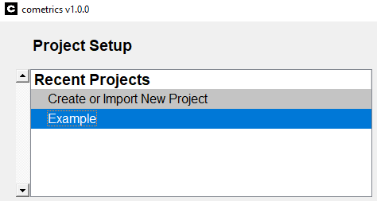

1. Create or import the session you wish to work on
   1. Right clicking a project will delete the project from the list

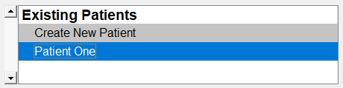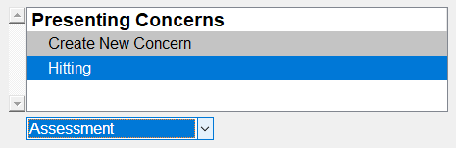

1. Create or select the patient being assessed
2. Create and add the presenting concerns in the session
3. Select whether this is an **Assessment** or **Treatment** phase

**Section 4** Keystroke File Setup

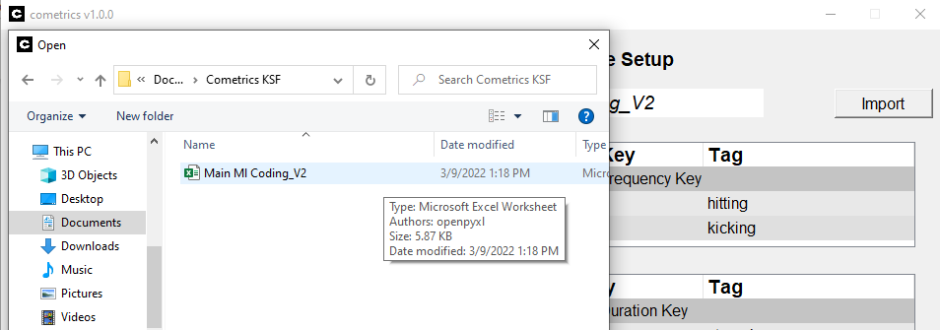

* This is done by **importing** an Excel spreadsheet associated with these codes
* If a file is not already uploaded, press **Import** to find and select the Excel file you wish to use for coding
* **Keystroke File Setup** is used to assign behaviors to keys when coding

**Section 4** Keystroke File Setup (cont.)

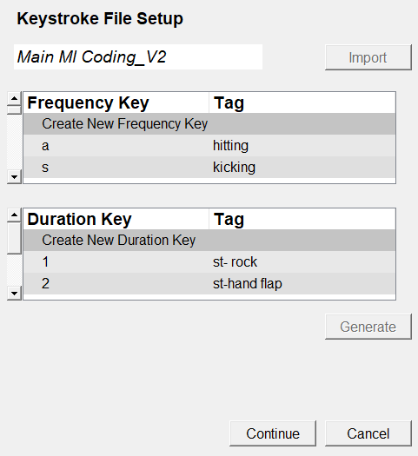

* Name of the selected Excel file
* Preview of the coding keys in the Excel file
* Select **Continue** in the bottom right to begin coding

**Section 5** Patient Information (Page 1)

**NOTE:** You will **not** be able to begin coding until all sections of **Patient Information** are complete (error messages will occur until the spaces are filled)

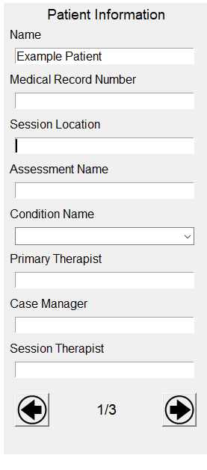

Induced stimulus that you are recording measures for

The name of the assessment

Where the session is happening

Unique identifier for patient

Name of case manager

* There are 3 **Patient Information** tabs

Name of session therapist

Name of primary therapist

Patient name

* Use the arrows to navigate the **Patient Information** tabs

**Section 5** Patient Information (Page 2)

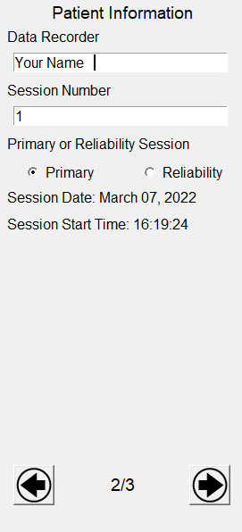

The date and starting time of the coding session

Identifying number for the session

Name of the person coding the video

Select if this is a Primary session (patient video) or a Reliability session (test for coder accuracy)

**Section 5** Patient Information (Page 3)

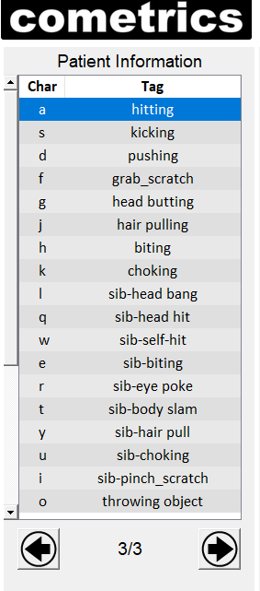

Page 3 of the **Patient Information** tab lists the keyboard characters assigned to each behavior tag

This will be automatically shown when the session is started

**Section 6** Session Times

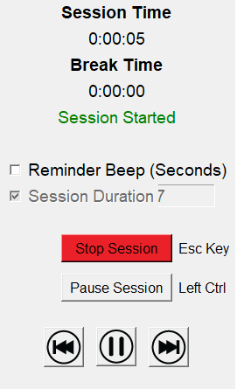**Section 7**  Key Bindings

* Used to go **Forward** in video by one second
* Used to **Play / Pause** video in video tab
* Used to go **Backward** in video by one second

Shows if session is Started **(green)**, Stopped **(red)** or Paused **(yellow)**

Records the amount of time spent paused

Records the amount of time spent coding

Pause / Resume the session

Start / Stop the session

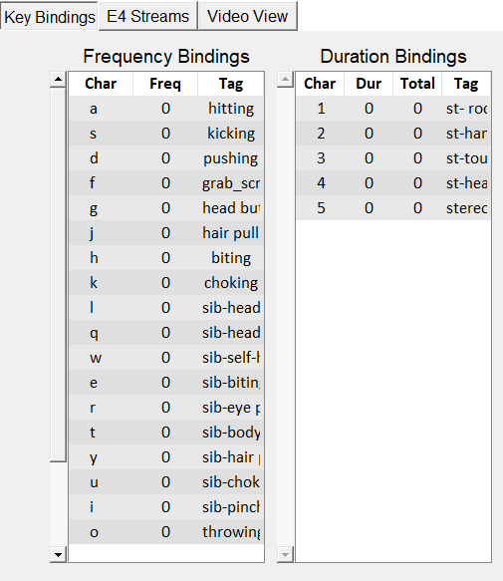

* The **Dur** and **Total** column records how long a code has been active per activation and per session, respectively
* The **Frequency** column shows the number of times a code has been used in the session
* The **Key Bindings** tab shows the **characters** tied to each behavior

**Section 7**  Key Bindings (cont.)

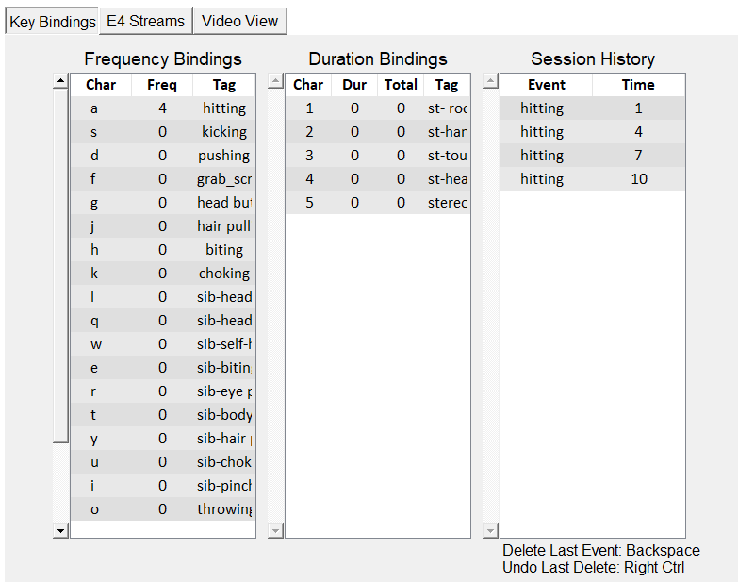

* Press **Backspace** to delete the last coded event
* Press the **Rightmost Control** key to undo the last deleted event
* The **Event** and **Time** columns show what behaviors have been coded during the session and at what time they occurred, respectively
* The **Session** **History** tab gives a basic view of what codes have been used and the time (in seconds) at which they occurred

**Section 7**  Key Bindings (Keyboard)

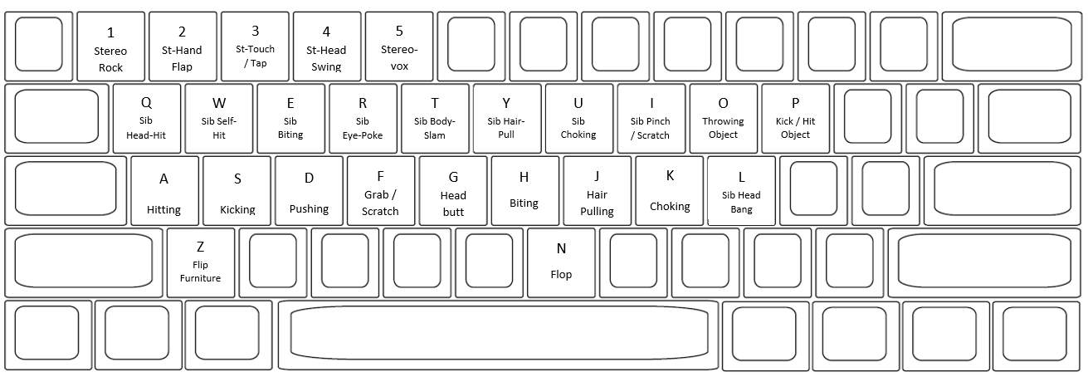

**\*\***For exact descriptions of each behavior, see **Operational Definitions** document

**\*\***See the **Coding Cheat-Sheet** for simplified descriptions of the behaviors and their keys

**Keyboard Close Up**

**Keyboard Codes**

**Section 8** E4 Streams

* **E4 Streams** tab displays physiological signals collected by the wristband

Body Temperature

Wristband Battery Life

Wristband Location

Heart Rate

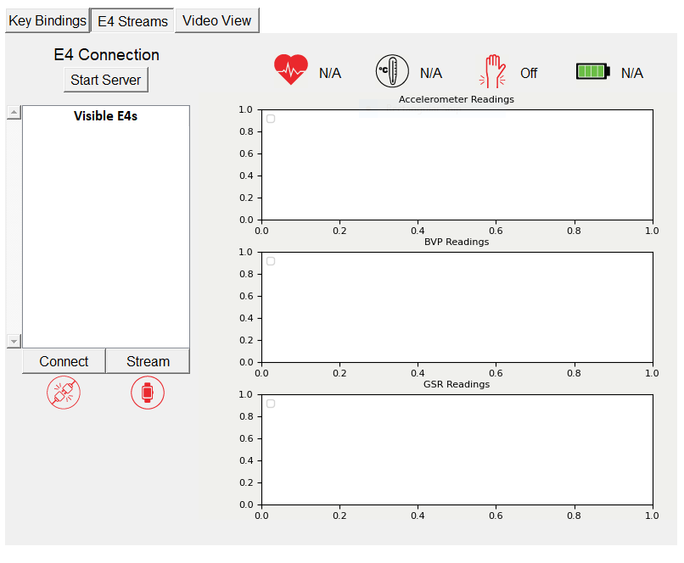

Connection status of wristband

Streaming status of wristband

**Section 8** E4 Streams (cont.)



* The **Visible E4s** tab shows the available wristbands that can be used to stream data

* Select **Connect** to connect the wristwatch to the cometrics program

* Press **Start Server** to begin utilizing the E4 wristband

* Select **Stream** to start streaming the data from the wristband to the cometrics program

**Section 8** E4 Streams (Icons)

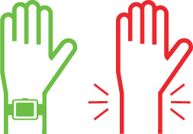

Wristband **on** arm

**Wristband Location**

Wristband **off** arm

≤ 100%

≤ 75%

≤ 50%

≤ 25%

**Battery Life**

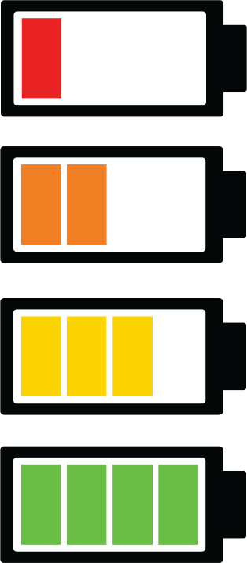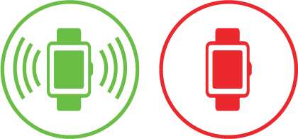

**Connection Status**

**Streaming Status**

Connected

Not connected

Not streaming

Streaming

**Section 9** Video View

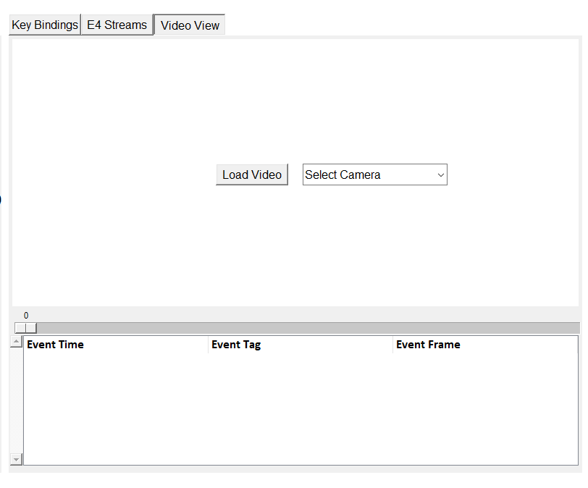

* To record from a connected **Webcam**, use the dropdown to select an input
* The **Load Video** button is used to select and upload the video you want to code
* The **Video View** window shows the video recording of the session
* After pressing **Load Video**, locate the video file you wish to upload

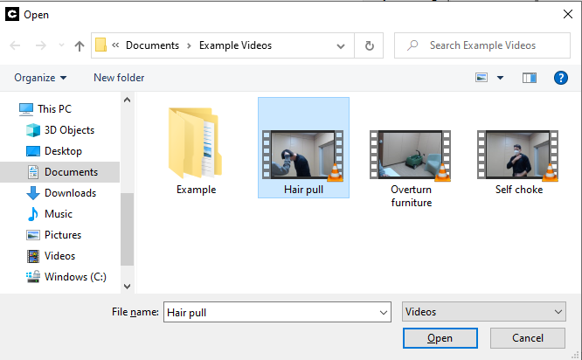

**Section 9** Video View (cont.)

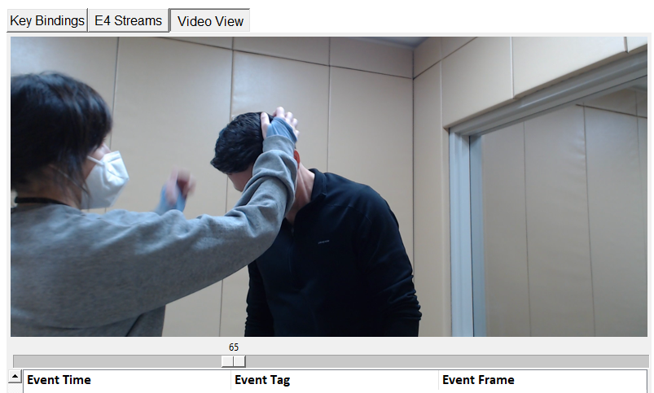

* Selected video will upload and be viewable for coding



* Used to **Play / Pause** video
* Used to go **Backward** in video by one second
* Used to go **Forward** in video by one second

**Section 9** Video View (cont.)

* When coding an uploaded video, the **Video View** tab will look like this. The individual codes given to the video are labeled by 3 characteristics: **Event Time, Event Tag, and Event Frame.**

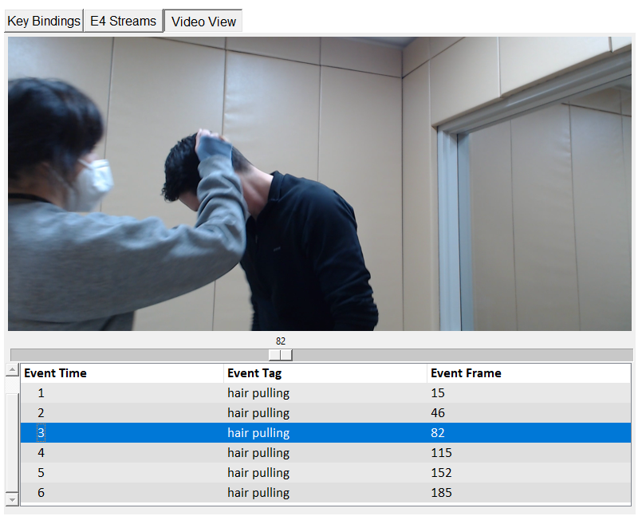

 **Section 9** Video View (cont.)

* Codes can be viewed underneath the **Video View** Tab
* The **Event Time** column breaks the video into more manageable sections. This makes it easier to recall the general time frame in which events occurred.
* This example video has 189 total frames. The **Event Time** column breaks this down into 6 sections.
* The **Event Tag** column shows the behavior assigned to the given code
* The **Event Frame** tab shows the specific frame where the coded event begins

**Section 9** Video View (Select Camera)



* Selected cameras can be used to **view, record,** and **code** sessions **live**
* The order of activation of connected **Webcams** is the order of the inputs on the camera dropdown menu
* Connected cameras can be selected for use in this tab
* To turn on the **Webcam** or other connected camera, press **Select Camera** and choose the desired input

**Section 10** Quick Access Menu

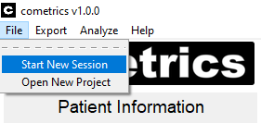

**Start New Session** – Reset the coding UI with the same settings

**Open New Project** – Close the coding UI and restart cometrics

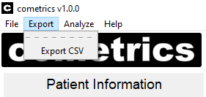

**Export CSV** –Used to export all existing session data for the patient into CSV files

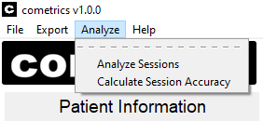

**Analyze Sessions** – Plots the session history for the patient into their KSF

**Calculate Session Accuracy** – Calculate the interobserver metrics between two sessions

**Analyze tab:** Used to export view recorded data and calculate session accuracy

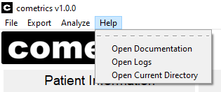

**Open Documentation** – Opens this guide using default PDF viewer

**Open Logs ­**– Opens the log file directory using File Explorer

**Open Current Directory** – Opens the working directory for the current patient

**Section 11** Keystroke File Format

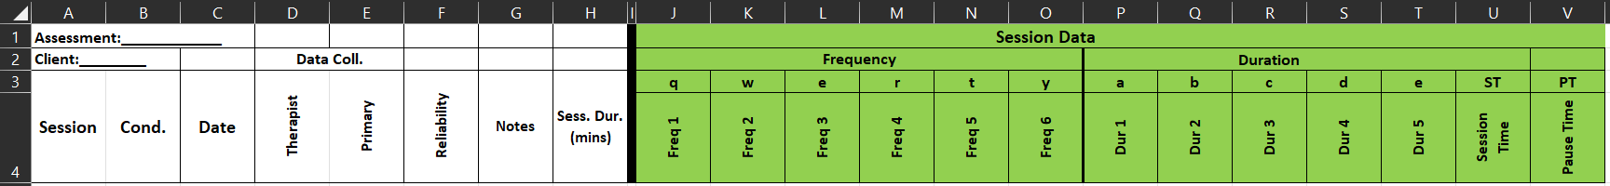

The keystroke file has a format that needs to be followed, an example of a working keystroke file can be found in the *references* folder of the root directory of the cometrics installation

The fields in the example keystroke file need to be present and when a new revision is created within the cometrics user interface, any custom fields or formatting are **not preserved**

**Section 12** Interobserver Agreement Coefficients

The calculation bin size can be adjusted in units of seconds, with 10 seconds as the default

Select which session will act as the primary session

When both sessions are selected the IOA coefficients can be calculated, the output file will be highlighted in the File Explorer

Select which session will act as the reliability session

The ‘Analyze’ tab in the menu bar will allow the user to calculate the interobserver agreement (IOA) coefficients between two sessions

Pressing this button will open the window to the right

Frequency Keys Partial Interval Agreement Percentage (PIA)

For each interval, x = smaller value / larger value

If both reliability and primary have zero value, then x = 1

Partial Interval Agreement = average all x values * 100

Frequency Keys Occurrence Interval Agreement Percentage (OIA)

Given that one observer scored 1 or more for an interval, agreement if both scored at least 1

If both observers recorded zero responses, the interval is excluded

Occurrence Interval Agreement = agreements / (agreements + disagreements) * 100

Frequency Keys NonOccurrence Interval Agreement Percentage (NIA)

Given that one scored 0 for an interval, agreement if both scored 0

If both observers recorded at least one response in the interval, then the interval is excluded

NonOccurrence Interval Agreement = agreements / (agreements + disagreements) * 100

Frequency Keys Exact Agreement Percentage (EIA)

Agreement is scored if both primary and reli have same value for an interval.

Exact Agreement Percentage = total agreements / total intervals * 100

Frequency Keys Total Agreement Percentage (TIA)

Agreement = # of intervals where both scored zero or > 1

Total agreement = number of agreements / total intervals * 100

Duration Keys Partial Interval Agreement Percentage (PIA)

For each interval, x = smaller value / larger value

If both reli and primary have zero value, then x = 1

Partial Interval Agreement = the average of all x values * 100

Duration Keys Exact Interval Agreement Percentage (EIA)

For each interval the value of the primary and reli is rounded to the nearest second

Agreement is scored if both primary and reli have same value for an interval.

Exact Agreement Percentage = total agreements / total intervals * 100

**Section 13** Session Output File Format

Each session has an output file that lists all collected information during a session including the Patient Information fields, keystrokes logged with timestamps from the timer, E4 frame, and video frame, where applicable, as well as all E4 data organized into one second windows

The session file is in JSON format, which is a human-readable file that is easily parsed in various programming languages

The file can be opened and read in a text file editor, such as Notepad

Additionally, sessions can be converted to comma-separated value (CSV) format using the button in the ‘Export’ tab

**Section 14** Configuration Changes

In the root directory of the cometrics installation is a file called *config.yml*, which defines several control variables for the software

The above user interface allows the user to modify this file. The “FPS” field allows the user to change the frames per second on the webcam feed. Values up to 30 FPS have been used, but the max FPS is dependent on your camera.

The E4 checkbox enables the recording of Empatica E4 data. The Woodway checkbox enables the control of a Woodway Split Belt Treadmill. The BLE checkbox enables the control of a BLE peripheral device.

The A and B fields allow the input of the serial numbers of the Woodway Split Belt Treadmill.

The “Clear Recent Projects” will delete all of the projects that are saved and shown during Project Setup.

**Section 15** Understanding Webcam Order

When cometrics starts up it will poll for all connected cameras, either integrated or connected via USB and the list indicated above will be populated in the order that cameras are found

Generally, this order is the same each time given the same cameras being connected, but there is no way to differentiate between cameras

The user will have to test each input to determine which camera is which input

**Section 16** Modifying Keystroke Files

**Key Tag** – The tag (behavior, label, etc.) that should be associated with hitting the specified key

**Key** – The key press that should trigger the recording of the specified tag

Pressing “OK” will add the key to the end of the displayed list

Pressing either of the two highlighted buttons will create a new key within the keystroke file

When a new key is created this way, the “Generate” button will be interactable and a popup will show

**Section 17** Connecting External Input

* **External devices** can be added via **Bluetooth** for use during coding. Connected devices (clicker, mouse, etc.) can be used as an **external button**
* First, the user must **connect** the desired device to their computer **via Bluetooth**
* In the Windows search bar in the bottom left, search for “**Bluetooth and other devices settings**”
* Click to open system settings



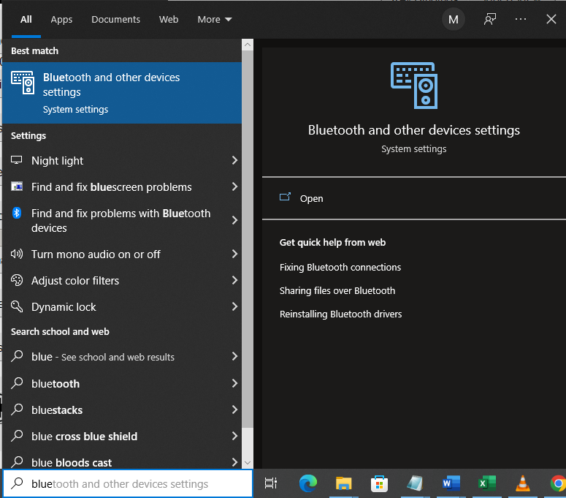

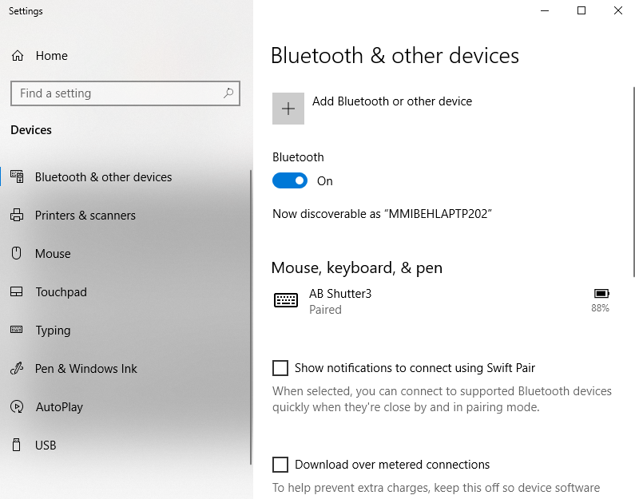

* The “Bluetooth and other devices” window will open
* Select “Add Bluetooth or other device”
* Make sure Bluetooth is turned on

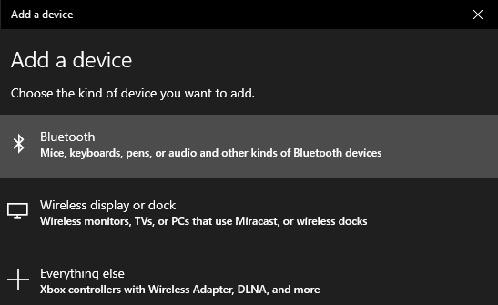

* The “Add a device” menu will open
* Select “Bluetooth” as the device type
* Find and select the desired device from the list of connectable devices
  + If the desired device is not listed, check that it is turned on / discoverable

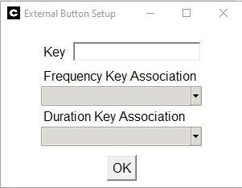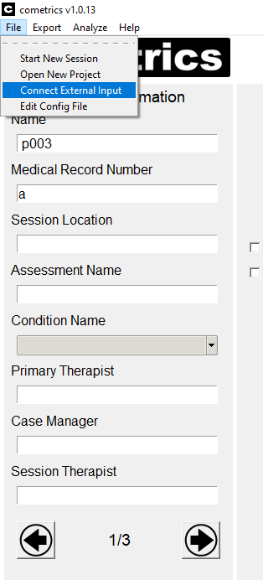

* The “External Button Setup” menu will pop-up
* Use the cursor to activate the “Key” input line. Press your external device to set it as the key

ch

* Select whether this button will be used as a Frequency key or a Duration Key
  + Select the specific behavior that will be assigned to the external button
* To setup an external button in **cometrics**, select “File” in the top left-hand corner.
* Select “Connect External Input”

**Section 18** Reporting Bugs and Other Issues

* Bugs and other issues found while using the cometrics program can be reported through the Munroe Meyer Institute Virtual Reality Laboratory GitHub page. The steps for reporting a bug are as follows:

1. Create or login to a GitHub account

<https://github.com/login?return_to=https%3A%2F%2Fgithub.com%2Fjoin>

1. Use the following link to access the Issues section of the cometrics’ GitHub <https://github.com/Munroe-Meyer-Institute-VR-Laboratory/cometrics/issues>
2. 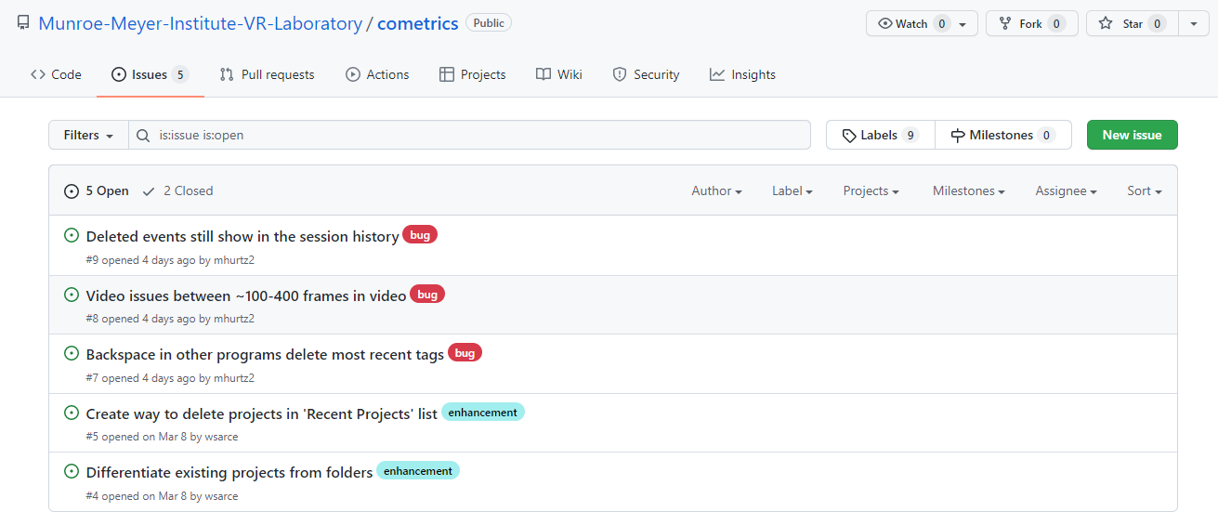Select the green “New Issue” button in the top right of the Issues page
   1. The Issues page is also used to view what bugs have already been reported, preventing repeated reports of the same bug
3. 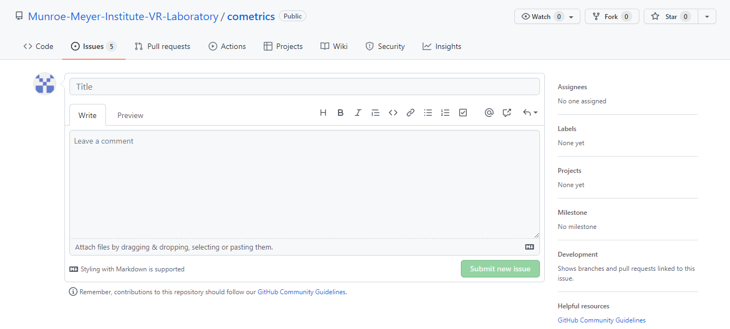The “Submit new Issue” page (pictured below) will open
4. In the “Title” section, provide a general description of the issue
5. In the “Leave a comment” section, write a detailed description of the issue (what happened, how it occurred, etc.)
6. Press the green “Submit new Issue” button in the bottom right to finalize bug report

**Section 19** Woodway Split-Belt Treadmill Support

**Section 20** BLE Peripheral Support